**Project 1**

Title

**Movie Renting Application**

Course

**CSC-17A**

Section

**42448**

Author

**Diego Montelongo**

Introduction

My first project that I created was a movie renting application. It is important because renting applications don’t necessarily just involve movies, but can also be adapted to other things for example renting a library book or renting hardware at your local hardware store. The rental business is a large multimillion dollar business that will never go out of business. Business trends may make some obsolete(video stores) but stores thrive on loaning items (Rent-to-Own). My program focuses on creating a customer with information pertinent to the customer and to the business in which it can use to manage its customers and serve as a foundation for a POS system.

Summary

Statistics



I only used one struct called customer to store all the information and stored that in a header file. Variables included in the struct were 6 that I used to store that information. I didn’t really use anything out of the other chapters that we covered that were not covered in this project. It was difficult however because I had a very time trying to construct the string array inside the struct customer that stores movies. For some reason I was able to store the data, but my program was not outputting the information of the movies correctly. After days of debugging and frustration, I somehow figured out that storing the data into the movies directly from cin instead of saving to a variable first allowed it to work. Coding the whole thing took me about 20 hours to do including the time it took me to scrap my first program I was going to do (program to collect and sort your cd and dvds at home). It took me about another 4 hours trying to figure out why my string array would not print. This was the most frustrating part because there was no reason it shouldn’t have been working.

Description:

I programmed the solution to the program by starting out with what I wanted the user to be able to do with the customer information. Some of the basic things like set and add payments and balances to customer account, change customer information. Then I looked at what other operations can be included that would be useful for a user to do.

Here is the input/output for each part of the program

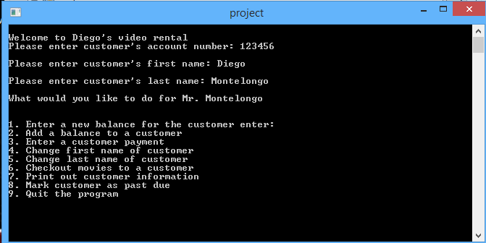

1. Enter a new balance for the customer option shown here:



1. Add a balance

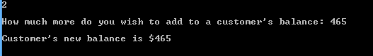

1. Enter a customer payment



1. Change first name

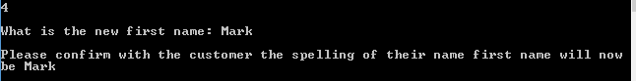

1. Change last name

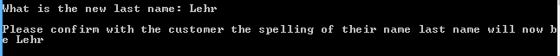

1. Checkout movies

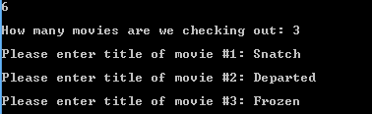

1. Print out Customer information

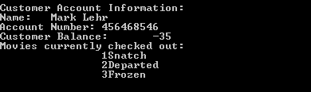

1. Mark customer as past due





References

Not much code borrowed or used from somewhere else. The only thing I did was google search what a good project would be and just got some ideas from that. That was the other hard thing to do was pick something that was challenging but still fell into the scope of our project.

Program Listing

